What is ASP.NET MVC?
The ASP.NET MVC is a web application development framework provided by Microsoft which is built on top of the .NET Framework. We can use this ASP.NET MVC Framework to develop web applications that provide a clean separation of code. The ASP.NET MVC framework is the most extensible and customizable framework provided by Microsoft.
The ASP.NET MVC Framework is based on MVC (Model-View-Controller) Design Pattern. So the point that I need to highlight here is ASP.NET MVC is a Framework whereas MVC is a Design Pattern.
The ASP.NET MVC Framework is not built from ground zero. You can consider it as an alternative approach to our traditional ASP.NET Web Forms Framework. As it is built on the top of the .NET Framework, developers enjoy almost all the ASP.NET features while working with the MVC application.
What is MVC?
MVC is an architectural software design pattern that is used for developing interactive applications where their user interaction is involved and based on the user interaction some event handling has occurred. It is not only used for web-based applications but it can also be used for Desktop or mobile-based applications where there are user interactions involved.
MVC design pattern was introduced in the 1970s that basically divides an application into 3 major components as Model, View, and Controller. The main objective of the MVC design pattern is the separation of concerns (codes), which means the domain model and business logic are separated from the user interface (i.e. view). As a result, maintenance and testing of the application become simpler and easier.

Introduction

MVC stands for Model View Controller which is not a programming language but it is a design pattern which use to develop the application. The application which has developed using MVC design pattern will get divided in 3 Components. Which Model will contain all the data which will get retrieve on the request of user. View will contain UI code and Controller will contain Business logic code.
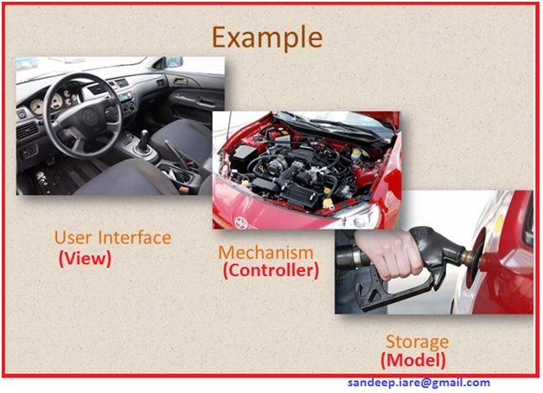
Figure: Graphical Example of MVC
The Properties of MVC is ,
- Loose Coupling
- Lightweight code
- Effective look
- Testing is Very Easy
- Rapid application integrated development.
MVC Architecture

The architecture of MVC can be seen in the following figure:
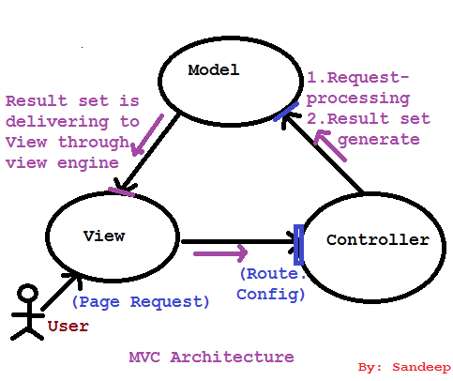
Figure: MVC Architecture
Explanation

User will make request for the page which user would like to retrieve. Requested page will go to controller and on controller Route.Config will be checked. Requested page will get transfer to Model from Controller.

On Model there will be 2 steps,
- Page initialization will get started.
- Then result set will be generated.
After these operation result set will get unload to View through view engine.

Responsibility of View Engine
- View Engine get the request from Controller
- The requested page will get executed
- The result got by the execution process will get deliver to View.
Life Cycle of MVC

Life Cycle of MVC as in the following figure:

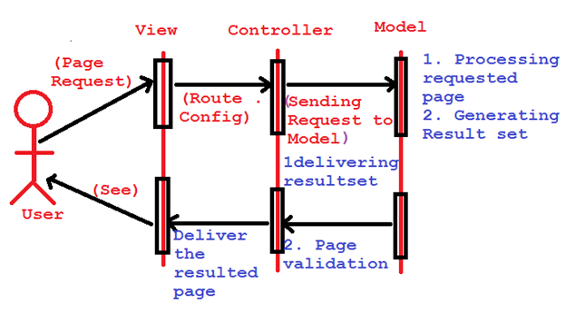
Figure: Life Cycle of MVC

Explanation of MVC Life Cycle

Step 1: User will make request for page

Step 2: Route.Config will get check on Controller

Step 3: After Route.Config validation request will get transfer from Controller to Model

Step 4: Page request will go to Model & on Model the following operation will perform.

a. Page initialization will start and after initialization of page
b. One result set will get generated

Step 5: Generated result set will get deliver to Controller from Model,

a. On Model Page validation operation will perform.

Step 6: After page validation on controller, Page will deliver to View through View engine.

Step 7: Now user can see requested page as response page.

Life Cycle of MVC can be seen as in the following figure:

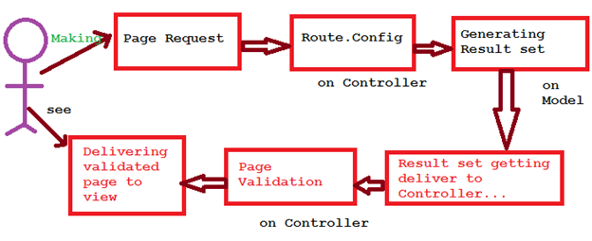
Figure: Life Cycle of MVC
Explanation:
- User will make page request.
- Route.Config of requested page will get checked on Controller.
- Page initialization will be performing on Model and after page initialization one result set will get generated.
- Generated Result set will be getting delivered to the Controller from Model.
- Result set will get validated (Page Validation) and after page validation Result set will get delivred to View through view engine.
Recap:

MVC Stands for Model View Controller, which is a design pattern. MVC based developed application will get divided in 3 components. Each and every component will contain their own code only.

How does the MVC Design Pattern work in ASP.NET MVC Application?
Let us understand how does the MVC Design Pattern work in the ASP.NET MVC application with an example. Let say we want to display the student details on a web page as shown in the below image.
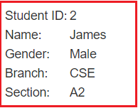
So, when the client (user) issues a request something like “http:/abc.net/student/details/2” from a web browser then the request is handled by the MVC framework as shown below.
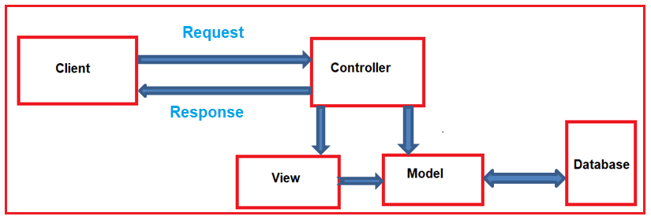
The controller is the component in the ASP.NET MVC application that actually receives the incoming HTTP request and then handles that request. In order to handle the incoming HTTP request, the controller does several things are as follows.
- The controller creates the model object that is required by a view. The model is the component in the MVC design pattern that contains a set of classes to represent the domain data or business data as well as logic to manage the data.
- The controller then selects a view to render the domain data or business data. The point that you need to remember is, while selecting a view, it is the responsibility of the controller to pass the model data.
- In the MVC Design Pattern, the one and only responsibility of a view is to display the model data. So, the responsibility of a view is to generate the necessary HTML which will render the model data or business data. Once the HTML is generated by the view, then that HTML is then sent to the client via the controller who initially made the request.
Now, I hope you understand the basic idea of the MVC Design Pattern. Let us discuss each of the components of the MVC design pattern in detail by comparing it with our example.
Model:
The Model is the component in the MVC design pattern that manages that business data or domain data i.e. state of the application in memory. The Model contains a set of classes that represent the data as well as logic to manage the data. So, in our example, the model is consists of Student class to represent the student data as well as StudentBusinessLayer class to retrieve the student data from any persistent medium like a database.
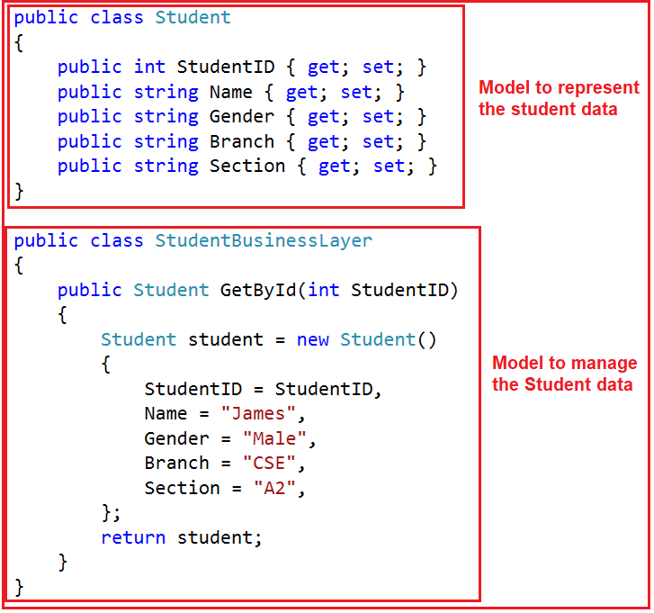
So in short, a Model:
- In ASP.NET MVC is basically a C# or VB.net class to represent the data as well as to manage the data.
- It is accessible by both controller and view.
- It can be used to pass data from controller action methods to a view.
- It can also be used by a view to display data on a page (HTML output).
View:
The view is the component in MVC Design Pattern which renders the model data as the user interface with which the end-user can interact. So, the View creates the user interface with data from the model. In our example, we want to display the Student information on a web page. So here the student model carried the student data to the view. This is the student model which should be supplied by the controller to the view. The following code does the same thing.
@model FirstMVCApplication.Models.Student
<html>
<head>
<title>Student Details</title>
</head>
<body>
<br />
<br />
<table>
<tr>
<td>Student ID: </td>
<td>@Model.StudentID</td>
</tr>
<tr>
<td>Name: </td>
<td>@Model.Name</td>
</tr>
<tr>
<td>Gender: </td>
<td>@Model.Gender </td>
</tr>
<tr>
<td>Branch: </td>
<td>@Model.Branch</td>
</tr>
<tr>
<td>Section: </td>
<td>@Model.Section </td>
</tr>
</table>
</body>
</html>
So in short, a View
- In ASP.NET MVC is a cshtml page.
- It contains all page-specific HTML generation and formatting code.
- A request to a view can only be made from a controller’s action method.
- The one and only responsibility of a view is to render the domain data or business data.
Controller:
The Controller is the component that contains the control flow logic. It is the one that will interact with both models and views to control the flow of application execution. The controller is the component in MVC Design Pattern that will handle the incoming HTTP Request. Based on the user actions, the respective controller will work with the model and view and then sends the response back to the user who initially made the request. In our example, when the client issued a request to the following URL
Employee.csHTML
Employee ID : <input id="Text1" type="text" /></br>
EmployeeName :<input id="Text1" type="text" /></br>
Employeeaddress :<input id="Text1" type="text" /></br>
EmployeeCity :<input id="Text1" type="text" /></br>
Gender :<input id="Text1" type="text" /></br>
Employeesalary :<input id="Text1" type="text" /></br>
<input id=" Submit" type="Submit" value="submit" />

Question:

Create a model class movie with fields title,releasing date ,genre,rating, price..
In view it should reflect in table format ..
And in a new page “movie releasing info “ there are pass data movie name,releasing date,price..

MovieController
public ActionResult Index()
{
Movie m = new Movie()
{
MovieTitle = "Jurassic Park",
genre = "fiveplus",
price = 1000,
rating = "five",
Releasedate = "22/09/21"

};
Movie m1 = new Movie()
{
MovieTitle = "amusement Park",
genre = "fiveplus",
price = 3000,
rating = "five",
Releasedate = "22/09/21"

};

Movie m2 = new Movie()
{
MovieTitle = "incredible Park",
genre = "fiveplus",
price = 4000,
rating = "five",
Releasedate = "22/09/21"

};
List<Movie> l = new List<Movie>()
{
m, m1, m2,
};
return View(l);
}
}
}
MOVIECONTROLLER (Transfer single value of each field)

public ActionResult Index()
{
Movie m = new Movie()
{
MovieTitle = "Jurassic Park",
genre = "fiveplus",
price = 1000,
rating = "five",
Releasedate = "22/09/21"

};

ViewBag.Movie = m;
return View();
}
}
}

(VIEW FILE(Index.cshtm))

<div>

@ViewBag.Movie.MovieTitle
@ViewBag.Movie.genre
@ViewBag.Movie.Releasedate
</div>

